Regional Impact of Inflation on Real Wage Growth
Regional Impact of Inflation on Real Wage Growth
ECON 501
Luke Alati, Geoff Feinstein, Ibukun Kolade, Rand Aldawish, Sizhe Liu
Background:
When discussing topics to focus on for our research project, our group was immediately intrigued by recent US inflation. It is a concept we are all too familiar with recently, and has impacted each of our lives. Going to the grocery store, filling a car up with gas, or shopping on Amazon, recent US inflation has raised prices across the board. Specifically, our group is interested in comparing recent price increases with wage increases. As master’s students about to enter the workforce, we have heard often about how wage increases have not kept up with inflation recently, and we wanted to investigate the validity behind this.
Beyond simply looking at the relationship between inflation and wages nationally, we aim to investigate the differences in the impacts of inflation on wages across the different regions of the United States. Regions across the United States have different industries, levels of immigration, tax, government incentives, and a variety of other factors that could influence the levels of inflation and wage growth. The tech-driven Silicon Valley starkly contrasts with the manufacturing of the Midwest. Therefore, we believe that analysis on the regional level is both necessary and could provide insight into regional variation. To do this, we turned to regression analysis. In addition to inflation, we incorporated other macroeconomic variables including unemployment rate, and real GDP. This led us to our research question: how has recent inflation impacted nominal wage growth across the regions of the United States?
Understanding the relationship between inflation and wage growth is crucial. If nominal wages are not keeping pace with rising prices, then real wages decline, potentially leading to decreased consumer spending, increased debt levels, and broader economic challenges. Insights from this study could potentially inform policymakers about regional disparities and encourage policymakers to address them.
Literature Review:
Inflation Inequality: Measurement, Causes, and Policy Implications by Xavier Jaravel discusses how inflation impacts different groups in society unevenly, especially across the income distribution. Lower-income households experience more inflation because they spend a larger share of their income on necessities that have rapid price increases (like food, energy, or housing). He highlights other potential drivers of this inequality, such as innovation, trade, and non-homothetic preferences. Using our data we should be able to estimate the average differences in inflation across different regions and demographics in the United States and see the income effect of inflation.
Factors Affecting Recent Food Price Inflation in the United States by Michael Adjemian discusses the debate in the field of economics about the main causes of the US inflation surge since 2021. The main potential causes are lockdowns, supply chain disruptions, and commodity shocks (e.g. Ukrainian wheat exports). In our data, we could potentially include lagged dummy variables such as when covid lockdowns began, or when the Russo-Ukrainian war began to estimate the effects of these events on overall US inflation.
This research is particularly relevant in understanding the broader socioeconomic impacts of inflation on wage dynamics in the U.S. As inflation persists, policymakers, economists, and businesses need insight into how different regions and population segments are affected. By disentangling the relationship between wage growth and inflation, this research can provide benefits in several aspects: policy strategies, labor market analysis, regional development, business strategy. This will possibly provide some insights for the policymakers on the impact of inflation across regions on wage growth.
In their study, Inflation Dynamics in the United States, Schmitt-Grohé and Uribe investigate the dynamics of inflation in the U.S. from 1900 to 2021, focusing on the permanent component of inflation. The rise in inflation lately after 2020 has brought attention to workers’ struggles in keeping up with their wages growth rate. The increasing prices due to inflation have hit middle income earners harder as their wages are not increasing at the rate. The reasons behind this include the increase in goods prices such as food, housing, and energy and disruptions in the supply chain leading to shortages, in critical industries. This situation makes negotiations over wages difficult as employers are hesitant to raise salaries significantly because of growing operational expenses. The time gap between spikes in inflation and adjustments in wage growth differs by region with some areas facing inflation effects based on their industry mix resulting in varying rates of wage growth, across different regions of the United States. Developing an understanding of this connection is crucial, for creating specific economic strategies to lessen the lasting effects of inflation on wages (Adjemian et al., 2023; Schmitt-Grohé & Uribe, 2022).

Data:
For our data, we came across an interesting comparison of wage increases and inflation on Statista. However, this comparison only went back to 2020, and the wage increase data was only an average value. We wanted data that went back before Covid, so we could have a baseline to compare to. Additionally, if we are to run a regression model, we need data that includes a variety of variables instead of a simple average for wage growth. Looking into the sources of the graph on Statista, we found that the wage data came from the Federal Reserve Bank of Atlanta, and the inflation data from the Bureau of Labor Statistics. We investigated the data from the Federal Reserve Bank of Atlanta, which eventually led us to a dataset that divided wage growth into a variety of subcategories. This dataset showed the wage growth for race, age, sex, education, industry, and importantly geographic region dating back to 1997. While there are many variables, each variable is a variant of wage growth for a specific demographic or region. All of the wage growth is computed monthly, giving us plenty of observations for a time series regression. In the dataset, an individual's percent change in wage in month t is computed as 100*ln(Wage_{t} / Wage_{t-12}). From the Bureau of Labor Statistics, we were able to download seasonally-adjusted CPI-U data, both as a value and as a 12-month percentage change, calculated monthly going back to 2017. When combining this data with CPI-U data, we are able to build a graph similar to the original Statista comparison of inflation and wage growth, but over a longer time frame and with additional variables so that multivariable regression analysis will be possible. We then decided to add other macroeconomic variables to the regression. From the Bureau of Labor Statistics, we found the monthly unemployment rate by region. From S&P Global, we found monthly nominal and real GDP, which we population adjusted using data from the Federal Reserve Bank of St. Louis.
Methodology:
Our analysis uses a fixed effects panel regression with region-level dummy variables to estimate the relationship between real wage growth and a set of economic variables, including: regional monthly inflation, regional unemployment rate, national population, national real GDP, dummy variables for each region, and a dummy variable for ‘post-COVID’s start’. Our regression was from January 2018 to August 2024, with monthly observations.
Specifically, our model was: ln(Real Wage Growth) = α + β(Monthly Inflation) + ∑β(Monthly Inflation * Region) + γ(ln(Unemployment Rate)) + ∑γ(ln(Unemployment Rate) * Region) + δ(ln(Population)) + δ(ln(Real GDP Index) + θ(Post) + θ(Post * Monthly Inflation) + ε
Our dependent variable is the log of real wage growth for region r at time t. α is a constant. β is capturing monthly inflation’s impact on real wage growth, and also includes interaction terms allowing inflation to impact each region differently. The unemployment rate’s effect on real wage growth is captured by γ, and also includes interaction terms. δ controls for different populations between regions, as well as the overall US economy’s Real GDP. We also included a ‘Post-Dummy’ to capture any systematic economic changes after COVID began to spread in early 2020, and an interaction term with post and inflation to capture any systematic changes in the relationship between inflation and wage growth due to COVID.
We also tested moving around where our ‘post’ dummy variable started in order to check the validity of our results. The original specification was for being after January 1st, 2020, to mark the start of COVID. We also tried setting ‘post’ after July 1, 2020, and January 1, 2021, as a robustness check. If the coefficients dramatically change, it may indicate that the initial date was not capturing the impact of the pandemic.
Key Findings:
Our fixed effects model shows that rising inflation is generally associated with a decline in real wage growth, with certain regions experiencing more pronounced effects than others. Specifically, we find that a one percentage point increase in monthly inflation corresponds to a 0.18% decrease in the Pacific region, which includes California, Oregon, Washington, Hawaii, and Alaska. While this effect is notably negative, it is relatively modest compared to other regions. The most substantial wage impacts of inflation are observed in regions with economies more heavily reliant on primary and secondary production rather than on tertiary services. Notably, the East South Central region, comprising Alabama, Kentucky, Mississippi, and Tennessee, is most affected, facing a 0.321% reduction in real wages per one percentage point increase in inflation. Similarly, the South Atlantic region (Florida, Georgia, North Carolina, South Carolina, Virginia, Washington, D.C., Delaware, and West Virginia) experiences a 0.284% decline, and the West South Central region (Arkansas, Louisiana, Oklahoma, and Texas) sees a 0.228% reduction. These findings suggest that regions more dependent on industries susceptible to commodity price fluctuations and manufacturing inputs are more vulnerable to inflationary pressures. In contrast, more service-oriented economies which can potentially adjust prices or rely on relatively stable input costs are less impacted.
Regarding temporal changes, our analysis initially did not detect any significant shifts in the relationship between inflation and real wage growth after 2020. While the model indicates that the effect of inflation on wages might be on average 0.04% stronger post-2020 across all regions, this difference is not statistically significant at standard significance levels. After the aforementioned re-coding of our 2020 dummy variables, our fixed effects model identifies a structural break in the relationship between inflation and real wage growth following the onset of the COVID-19 pandemic. The findings show that the negative impact of inflation on wages was exacerbated after mid-2020, with the magnitude of this effect increasing significantly. Using a cutoff date of July 1, 2020, the estimated effect of inflation on real wages was, on average across all regions, 0.06% stronger, while the January 1, 2021, cutoff shows an even greater increase of 0.07%. Both estimates are statistically significant at the 5% level, highlighting a meaningful shift in how inflation affects wage dynamics during and after the pandemic. Despite this structural break, the ranking of regions most affected by inflation remains unchanged, reinforcing the robustness of our earlier findings. Regions such as East South Central, South Atlantic, and West South Central continue to experience the most substantial wage growth declines due to inflation. This consistency across time validates the model’s reliability in identifying regional disparities in inflation’s impact.

Conclusion:
Our research aimed to explore the relationship between inflation and wage growth across different regions in the United States by using a fixed-effects panel regression model. We observed a consistent negative relationship between inflation and real wage growth. For instance, in the Pacific region a 1 percentage point increase in monthly inflation correlates with a 0.18% decrease in real wages. Wage growth varies significantly across regions. This suggests that regional economic structures, dominant industries, and policy environments might play a role in mediating the impact of inflation. From our post-2020 structural break, we found that the COVID-19 pandemic exacerbated the negative impact of inflation on real wages. An inverse relationship between unemployment and GDP underscores the importance of economic growth in maintaining employment and mitigating wage stagnation.
Our conclusions above have led us to think more about the challenges brought by inflation and these policy insights. Regions most impacted by inflation (e.g., East South Central and South Atlantic) require tailored interventions such as wage subsidies, investments in high-growth industries, and tax incentives to attract businesses and stimulate wage growth. Targeted fiscal and monetary policy could mitigate the effect of inflation on real wages. For example, region-specific tax breaks or temporary subsidies on essential goods can alleviate the cost-of-living pressures in regions most affected. Collaborative efforts between federal, state, and local governments are essential to align fiscal policies with regional needs. For example, combining federal investments with state-level workforce development programs could address disparities more effectively.

Our study does have some limitations that we should point out. Aggregating data at the regional level may obscure localized variations in inflation’s impact on wages. The analysis of the post-2020 structural break is limited to a relatively short time frame, making it challenging to assess longer-term impacts or distinguish between temporary and permanent changes. The model does not explicitly include the effects of region-specific policies (e.g., minimum wage adjustments, tax incentives) or account for lag effects between policy implementation and observable outcomes. The structural break analysis assumes uniform effects of COVID-19 across regions. However, the pandemic’s economic impact varied significantly by state and industry, potentially skewing results. Real wage calculations focus solely on monetary compensation, excluding benefits such as healthcare, pensions, and other perks. Some explanatory variables, such as unemployment and GDP, might be endogenous, potentially biasing the regression estimates.
If we were to continue this research, we would continue refining the model by adding more macroeconomic variables, incorporating more data, and further investigating regional disparities. Additionally, we would examine how inflation and wage dynamics differ across industries within regions to refine policy recommendations further. We could expand our research further to include earlier years, and study the long-term consequences of inflation on wage growth and employment trends to guide sustained policy interventions. Finally, we would conduct a study of the structural break for a longer period of time so as to better understand its existence and its impacts.
Regression Output:
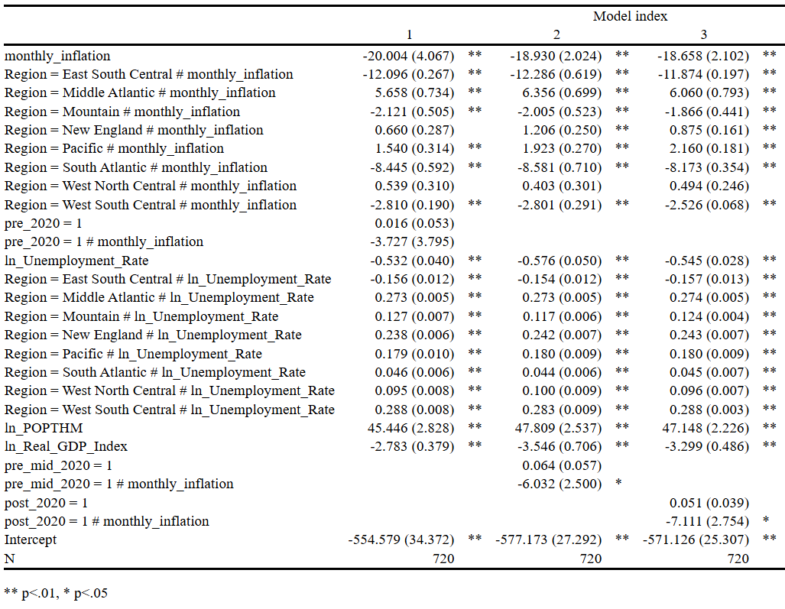
Note: The dependent variable is the natural log of real wage growth. Inflation, unemployment rate, and wage growth are in raw units (e.g. 1% = 0.01). Population is in thousands.
Sources:

Literature Review:
Adjemian, M. K., & Others. (2023). Factors affecting recent food price inflation in the United States. American Journal of Agricultural Economics, 105(2), 567-593.
Coibion, O., Gorodnichenko, Y., & Weber, M. (2022). Inflation expectations as a policy tool? Annual Review of Economics, 14, 423-447.
Jaravel, X. (2020). Inflation inequality: Measurement, causes, and policy implications. Journal of Economic Perspectives, 34(1), 123-148.
Leibovici, F., & Santacreu, A. M. (2021). The COVID-19 pandemic and the future of global value chains. Applied Economic Perspectives and Policy, 43(1), 150-163.
Schmitt-Grohé, S., & Uribe, M. (2022). Inflation dynamics in the United States, 1900-2021. Review of Economic Studies, 89(3), 876-905.
Uluk, M. (2021). COVID-19 and the inflation surge. Unpublished Manuscript. Columbia University.

Data:
https://www.statista.com/statistics/1351276/wage-growth-vs-inflation-us/
https://data.bls.gov/dataViewer/view/timeseries/CUSR0000SA0
https://www.atlantafed.org/chcs/wage-growth-tracker
https://fred.stlouisfed.org/series/POPTHM
https://www.spglobal.com/marketintelligence/en/mi/products/us-monthly-gdp-index.html#:~:text=We%20calculate%20the%20MGDP%20in,our%20archives%20of%20the%20MGDP.

Previous Work
Key Findings:
The coefficient on Monthly Inflation (without interaction) is -20, indicating that higher inflation is associated with significantly lower real wage growth. This strong negative effect is statistically significant at the 1% level. Note that this is the estimated effect for the base region, East North Central.
The coefficients on monthly inflation interacted with each region suggest that there is regional heterogeneity in the effects of inflation on real wages between regions. Note that all of these coefficients are relative to the East North Central region. The coefficients are as follows. East South Central had -12.1, Middle Atlantic had 5.66, Mountain had -2.12, New England had 0.66, Pacific had 1.54, South Atlantic had -8.45, West North Central had 0.54, West South Central had -2.81. All of these estimates were significant at the 5% level with the exception of West North Central, which did not appear to have a statistically significant difference from East North Central.
The coefficient for the interaction between the pre-2020 dummy and monthly inflation is -3.73, with a p-value of 0.355. This term represents a potential shift in the inflation-wage growth relationship before and after the specified cutoff date, independent of any specific region. This result is not statistically significant, so there is no strong evidence that the inflation effect on wage growth changes substantially when comparing the pre-2020 period to the post-2020 period for the sample as a whole.

When the cutoff date for the time-period dummy was initially set to January 1, 2020 (using the “pre_2020” dummy), the interaction between the pre-period indicator and inflation was not statistically significant. This suggested that there was no clear change in the inflation-wage growth relationship starting exactly at the beginning of 2020. After redefining the post-period to begin in mid-2020, the interaction between the pre-dummy and inflation became statistically significant at the 5% level with a p-value of 0.042. This indicates that the inflation-wage growth relationship did indeed shift, but that the shift is more detectable if we assume the structural break occurred a bit later in the year. Rather than an immediate change at the start of 2020, the data suggest that labor markets and wage dynamics may have adjusted to new conditions during the middle of 2020. Similarly, moving the cutoff to the start of 2021 also produced a statistically significant interaction (p-value of 0.033), reinforcing the finding that the break in the relationship is more apparent once we allow the post-period to begin sometime after the initial onset of the pandemic. By adjusting the cutoff date, we gain evidence that a structural shift is indeed present, but it likely happened in the months following the initial shock, rather than hitting right at the start of 2020.

